**Training Logs Plots**

**Time Series Data:**

1. **Learning Rate:**

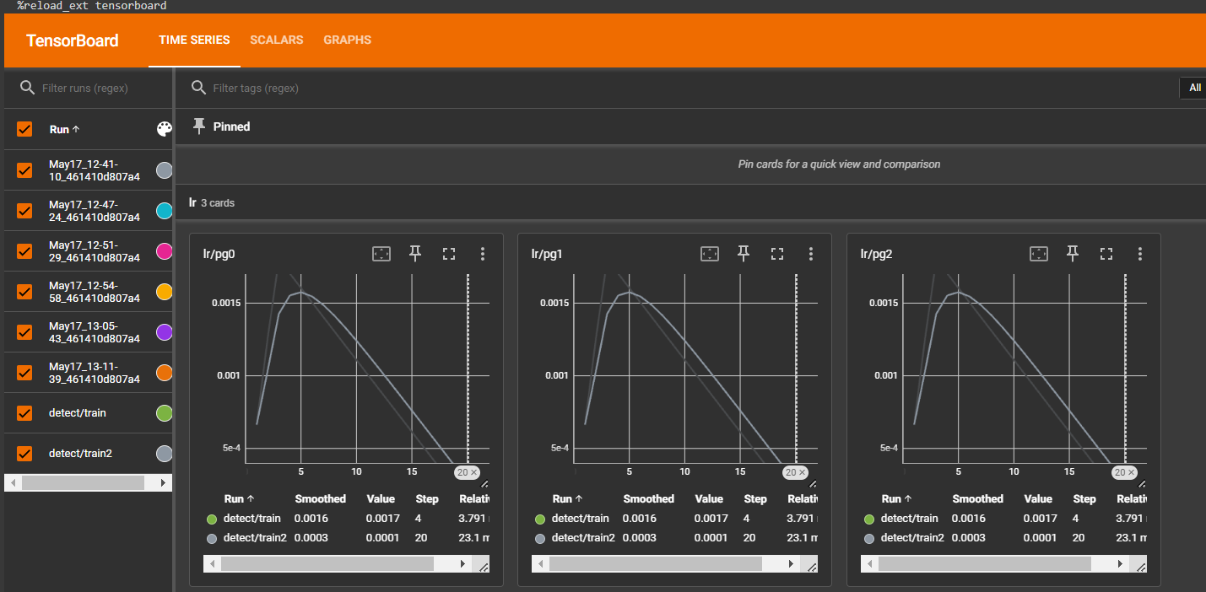

1. **Metrics (mean Average Precision, Precision and Recall plots)**

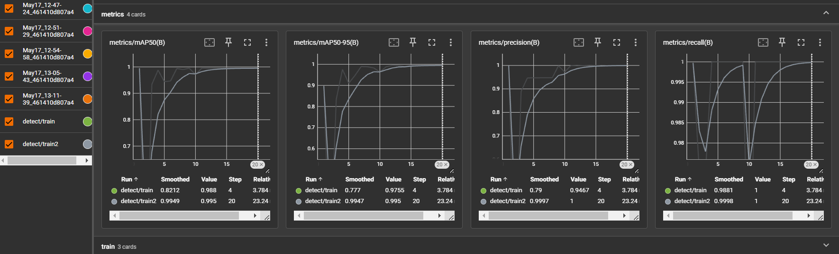

**Scalar Plots:**

1. **Learning Rate:**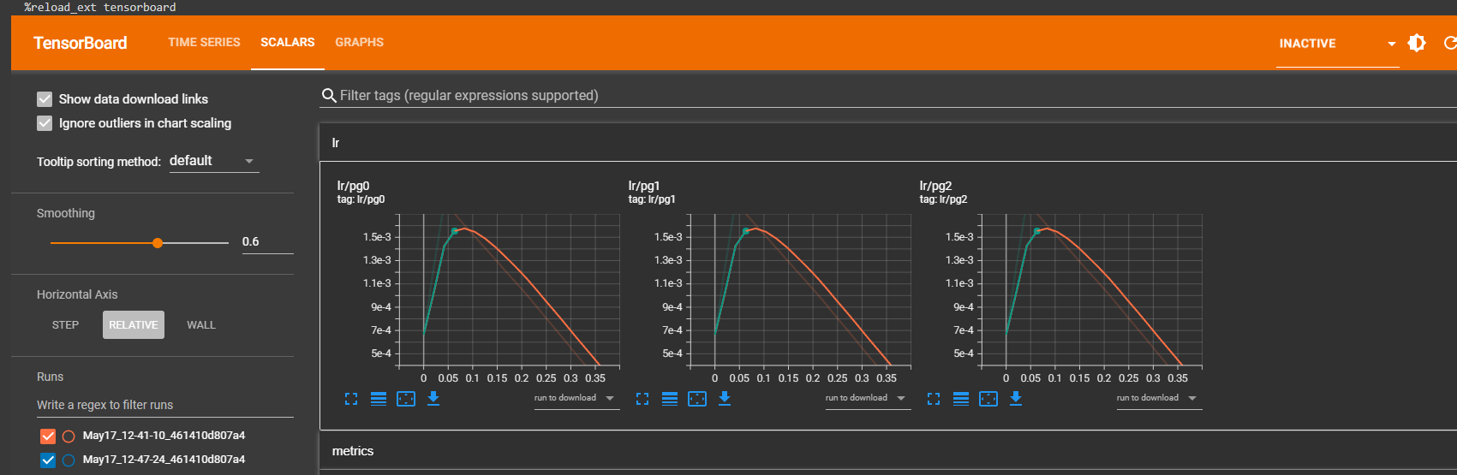
2. **Train:**

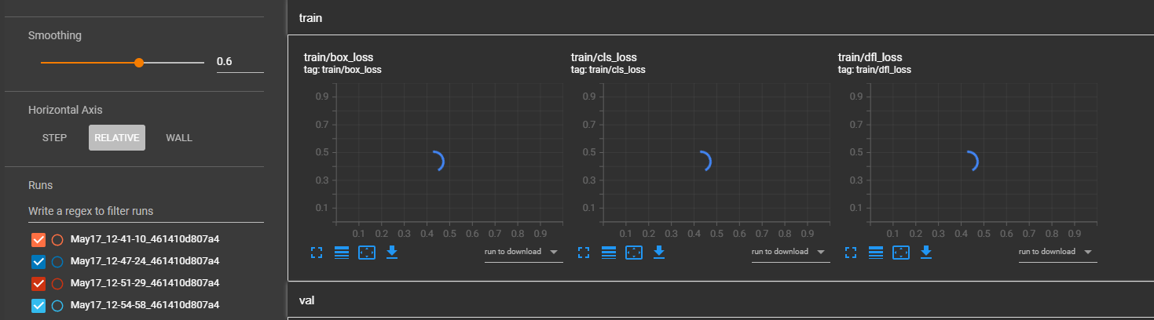

Im sorry they have been loading for a long time and the possible solution to this is to run the training again But i have run over the google colab GPU runtime limit,(will update this if i am able to get it to run  
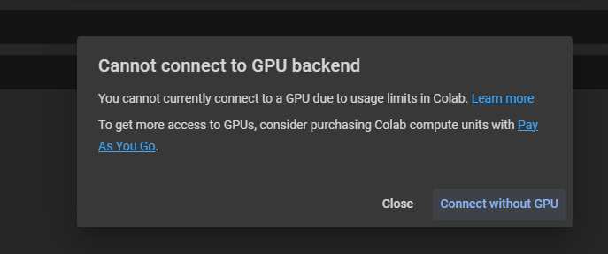

1. **Validation:**

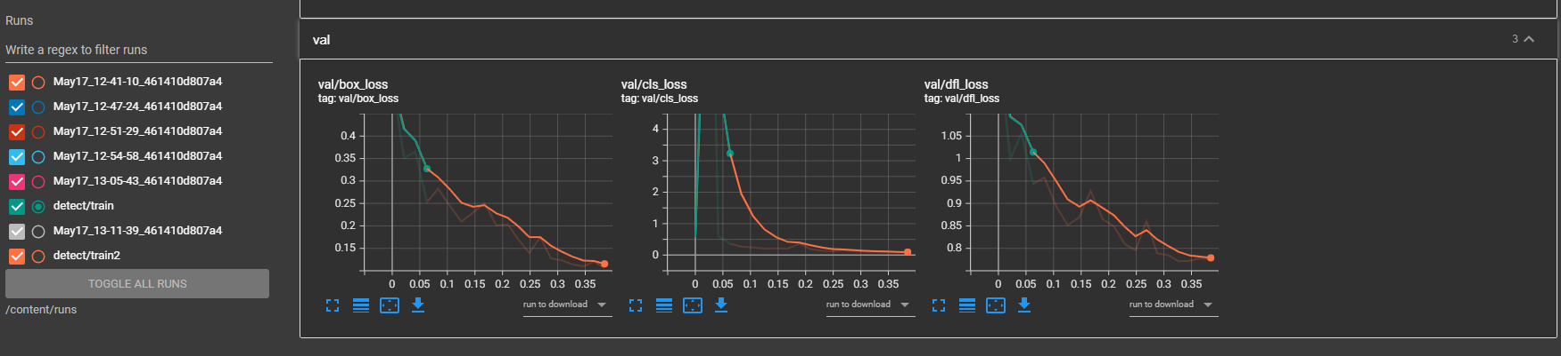

**Link to Google Colab File-**  [TrainYOLOV8.ipynb](https://colab.research.google.com/drive/1WqEG036T0XGfzIV9XNHfM7NoJ6-7Cm3h?usp=sharing)

**Running Examples:**

**Full video demonstration -**Demonstration on task video - [Graymatics Demonstration.mkv](https://drive.google.com/file/d/1yAOZwlLS55Iy3XIPF3o3ntXu_04aRRjc/view?usp=sharing)

Examples from the video(Screenshots):  
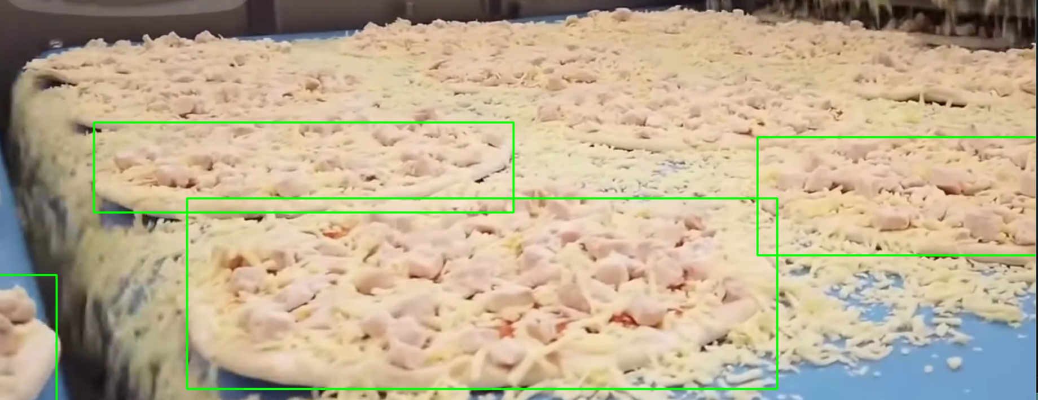

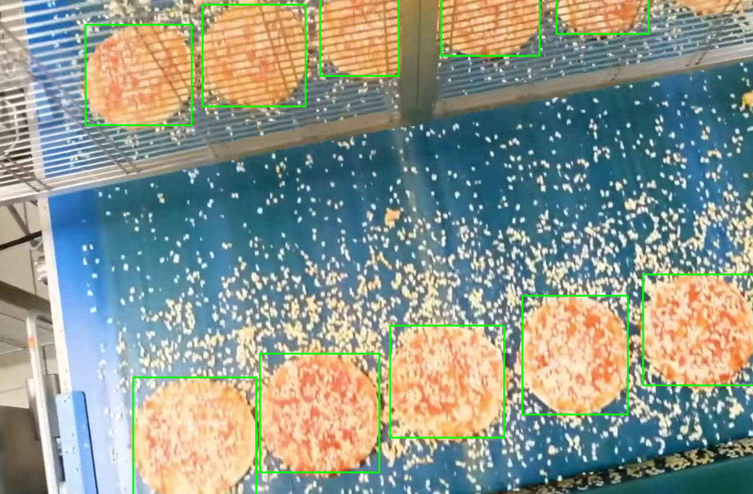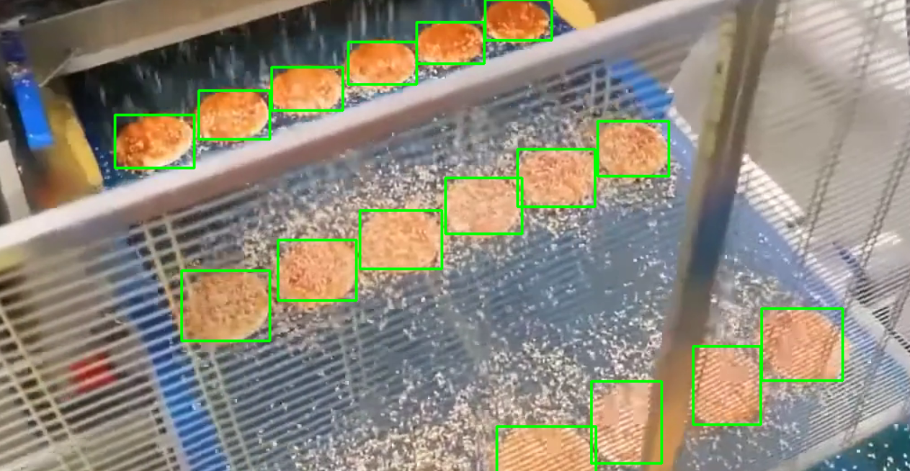

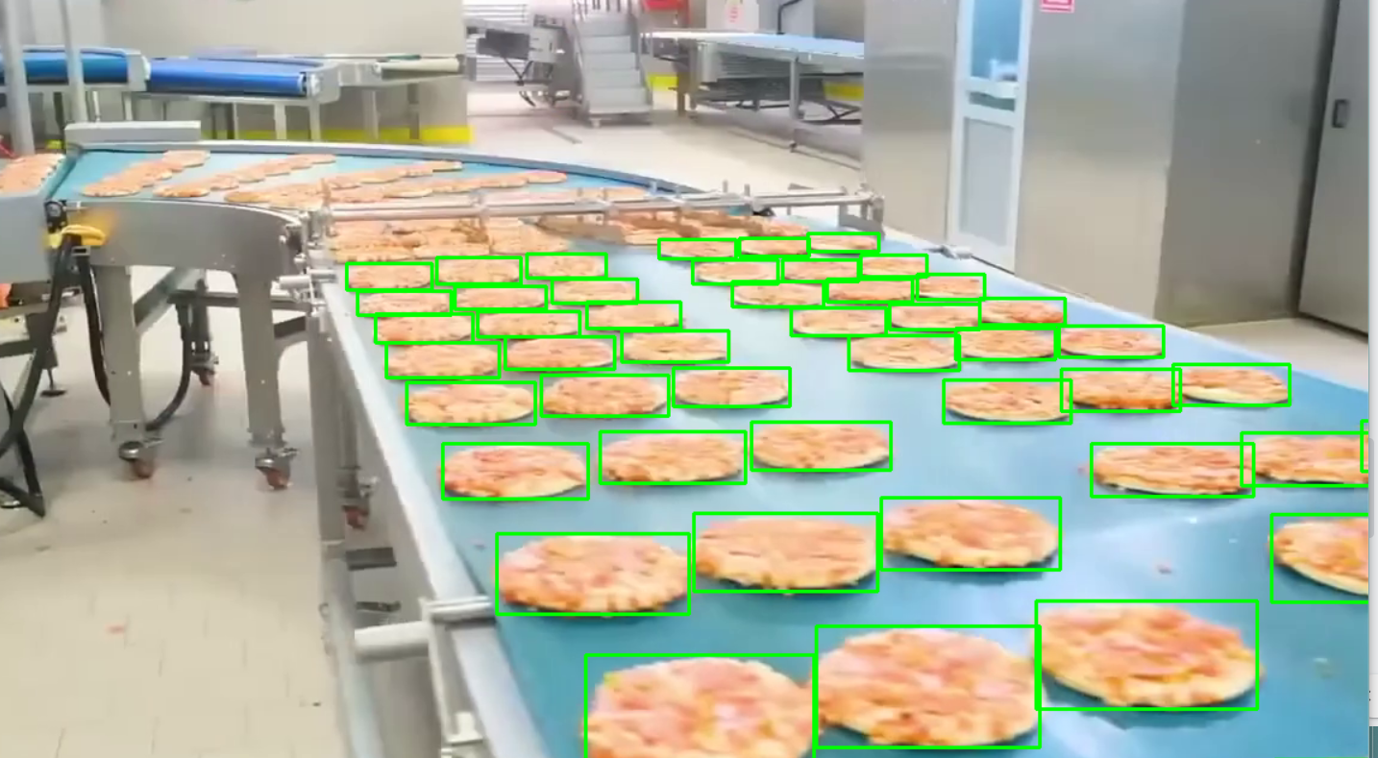

Far away pizzas were not detected.

**Other examples (running on other random pizza videos to check for potential overfit)**

